12. Creating and managing index estooptimize database performance.
use school;
show databases;
CREATE TABLE employees3 (
id INT AUTO_INCREMENT PRIMARY KEY,
name VARCHAR(100),
email VARCHAR(100),
department VARCHAR(50),
hire_date DATE
);
INSERT INTO employees3 (name, email, department, hire_date)
VALUES
('Roma', 'roma12@gmail.com', 'IT', '2020-01-15'),
('Mona', 'mona34@gmail.com', 'HR', '2021-03-10'),
('Riya', 'riya89@gmail.com', 'IT', '2019-07-22'),
('Divya', 'divya76@gmail.com', 'Finance', '2022-11-01');
SELECT*FROM employees3;

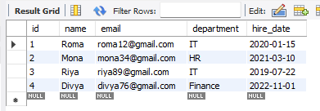

--Step 4: Create indexes
-- Index on ‘name’
CREATE INDEX idx_emp_name ON employees3(name);
--Unique index on ‘email’
CREATE UNIQUE INDEX idx_emp_email ON employees3(email);

--Composite index on ‘department’ and ‘hire_date’
CREATE INDEX idx_dept_date ON employees3(department, hire_date);

--Step 5: View indexes

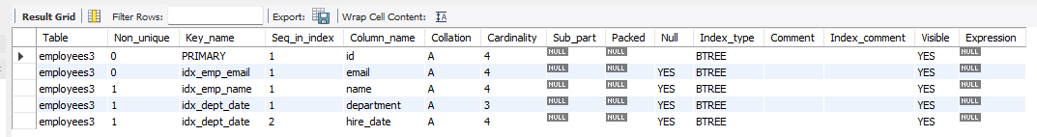

--step 6: Use EXPLAIN to see if index is used
EXPLAIN SELECT*FROM employees3 WHERE name= 'Roma';

